Supplementary Material
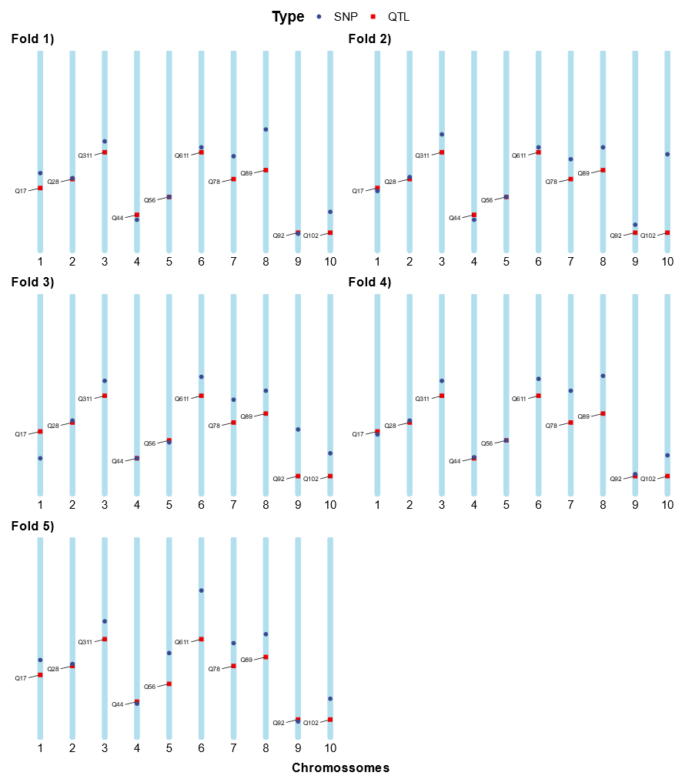
Supplementary Figure S1. Genetic maps illustrating the markers selected through Multivariate Adaptive Regression Splines (MARS) (dark blue dots) in scenario SC1. In this scenario, the trait exhibited a heritability of 0.4 and was controlled by 10 QTLs (red dots), with each of them positioned on distinct chromosomes (light blue lines). The plots presented in the Figure correspond to folds 1, 2, 3, 4, and 5, respectively.
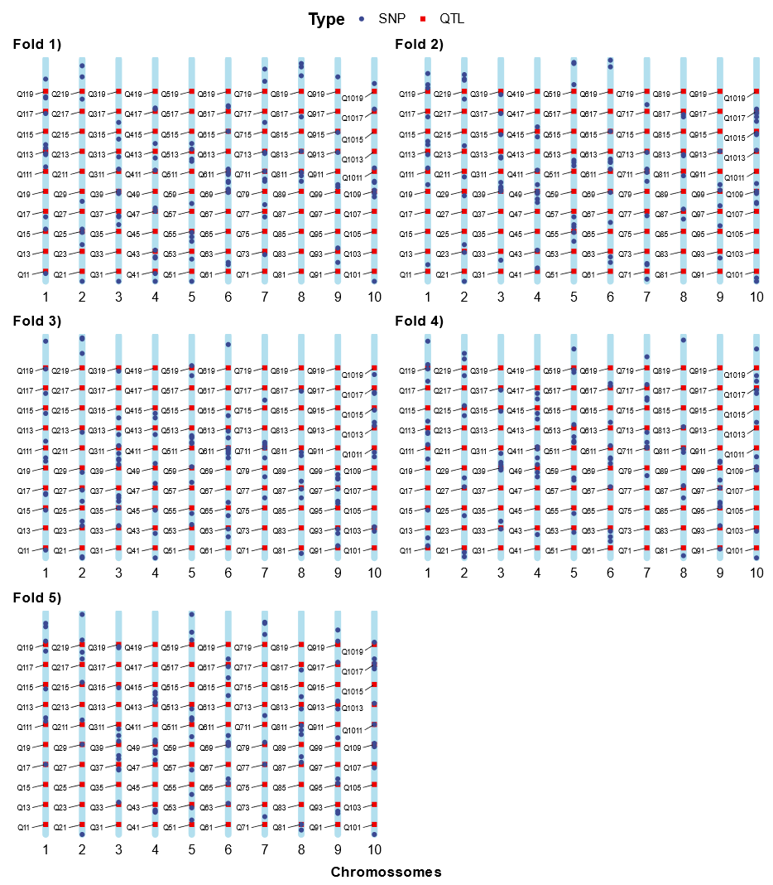
Supplementary Figure S2. Genetic maps illustrating the markers selected through Boosting, utilizing 5% of the most significant markers (dark blue dots), in scenario SC2. In this scenario, the trait exhibited a heritability of 0.2 and was controlled by 100 QTLs (red dots), with ten of them positioned on distinct chromosomes (light blue lines). The plots presented in the Figure correspond to folds 1, 2, 3, 4, and 5, respectively.

